2017-18 Jefferson County Educational Service Center

Sponsor Annual Report

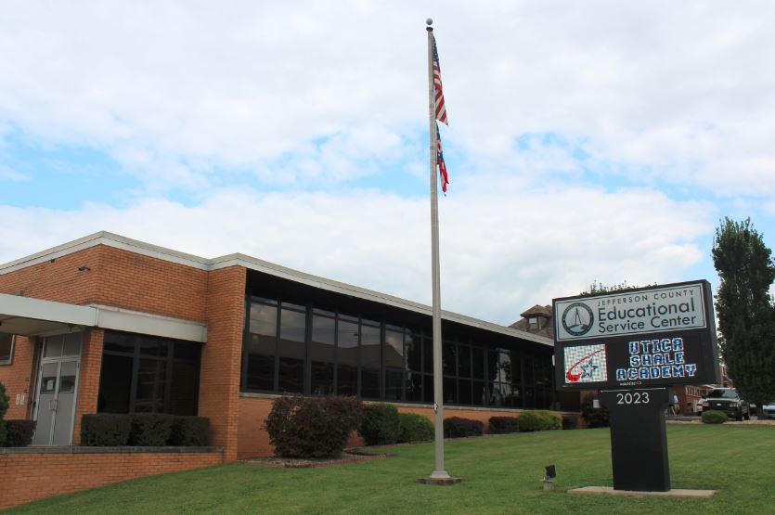

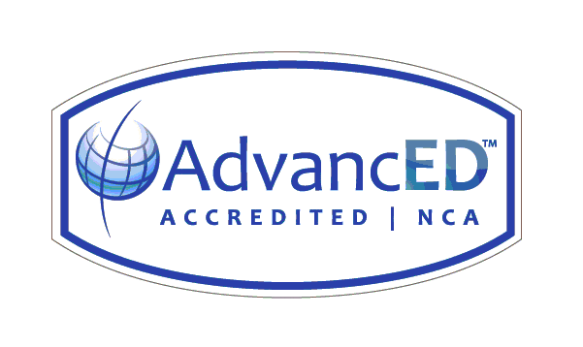

VISION

The Jefferson County Educational Service Center will be a leader in educational advancement by providing services and programs to political subdivisions and educational institutions.

MISSION

To build capacity through innovative cost effective programs.  To improve partnerships and collaborate with educational institutions, families, and communities within public and private settings.

BELIEF STATEMENTS

We Believe:

■ our employees drive our success.

■ in being financially strong to provide leadership and services that result in educational  
   opportunities for all.

■ in providing service-oriented, data-driven, and cost-effective programs.

■ in the importance of increasing student achievement and enhancing teacher instruction.

■ in collaborating to enrich life-long learning opportunities.

■ in 21st Century learning and technology programs.

About Jefferson County ESC

|  |
| --- |
|  |
|  |
| The Jefferson County Educational Service Center (JCESC) was one of 88 county school districts established in 1914 by the Ohio General Assembly.  County school districts were charged with responsibility for elevating the state’s system of education to a proper standard, and the work of county staff was primarily regulatory and compliance-driven.  Staff developed courses of study, provided teacher in-service training, and supervised classrooms.  In 1995, county school districts were renamed educational service centers, a title that appropriately describes a shift in focus from compliance to service and reflects the current work of ESCs.  Today, JCESC embraces a system-wide culture of service that begins with the leadership of the Governing Board and extends across all licensed and classified staff.  In response to constituent needs, JCESC   * provides high quality professional development embedded in the National Staff Development Standards, for district administrators and teachers, * coordinates collaborative programs for constituent districts to eliminate duplication of human and financial resources, * participates in interagency collaborative programs across Jefferson and Harrison Counties to provide efficient, cost-effective responses to at-risk student issues, * collaborates with higher education in leadership initiatives, * provides collaborative, cost-effective direct services for students with disabilities, * administers the Virtual Learning Academy, an e-learning program that preserves district student and fiscal bases across the State, Country and Internationally, and * sponsors the The Jefferson Health Plan, a partially self-funded health insurance program serving more than 250 school districts and political subdivisions |

Governing Board

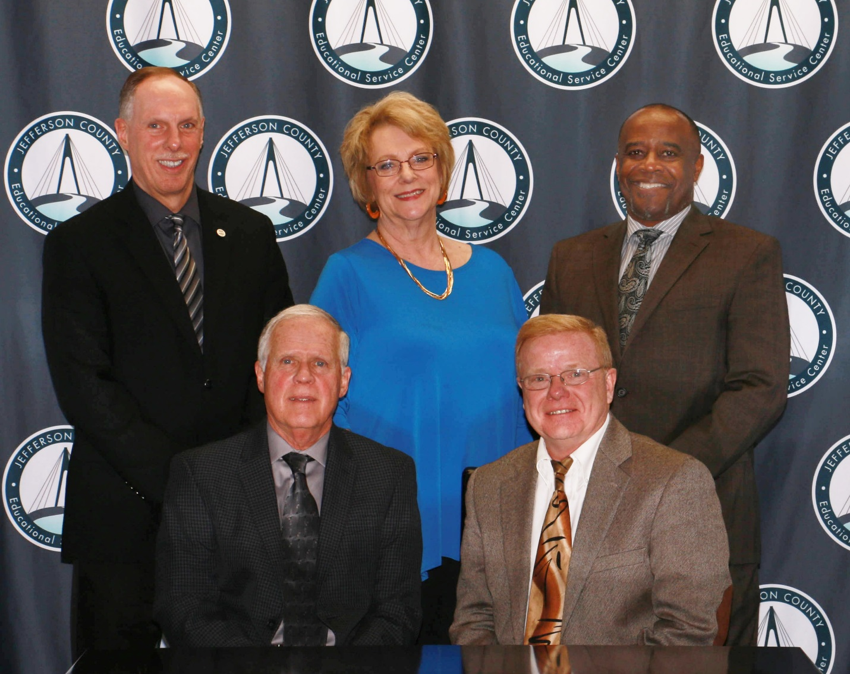

Robert L. George, President

William Schaefer, Vice President

Barbara Cunningham

Barry Gullen

Mark Johnson

Dr. Chuck Kokiko, Superintendent

Don Donahue, Treasurer

Community School Sponsorship Staff

Dr. Charles M. Kokiko

Mr. Don Donahue- Fiscal

Mr. Dan Spahn- Legal

Mr. Jeff Oblak - Special Education/Transportation

Mr. Mark Masloski- Education

Mr. Pat Keenan- Technology, buildings and grounds

Mr. Ron Sismondo- Professional Development

Ms. Linda Lenzi- Gifted Education

Mrs. Karen Martin-Epicenter

**Rigorous Review and Consideration of New School Proposals and Renewal Applications**

Achieving and maintaining charter school quality begins with a rigorous but fair process for reviewing new school proposals. The review process is comprehensive, including the following:

* the proposal educational model
* fiscal viability
* governance
* operations

JCESC reviews each application. Feedback is provided to new school applicants to whom preliminary agreements are offered. A similar rigorous process is conducted for schools that seek to renew their sponsor contracts.

**Attendance and participation at monthly governing authority meetings**. Participation in these meetings not only supports efforts to provide strong oversight and monitoring of school activities, but also allows for timely, relevant sharing of data, information and technical assistance as board members and school leaders discuss and take action on issues that ultimately impact school compliance and student achievement.

**Comprehensive compliance assessments**. JCESC conducts thorough reviews and school site visits - including opening assurances, and comprehensive fall and spring assessments - to help ensure school compliance with state and federal laws, and with the terms of the sponsorship contract. Special education reviews are also conducted to help ensure compliance and the school is adequately meeting students’ needs.

**Quality technical assistance**. School leaders and others participate in the many training sessions coordinated by JCESC to address the school’s common needs in core areas of health and safety, special education, and Ohio law compliance. Beyond these broad-interest training opportunities, JCESC provides one-on-one technical assistance to board members and school staff to help address their unique individual needs, offering feedback aimed at improving student achievement. Additionally, JCESC provides oversight and guidance in support of the school’s Comprehensive Continuous Improvement Plan, helping the school to gain access to much-needed federal funding and providing support to help ensure compliance with federal requirements. JCESC spent significant devoted time and resources assisting schools with attendance audits in light of new seat time verifications for blended and online schools.

**Monthly fiscal reviews**. JCESC’s school treasurer coordinates monthly fiscal reviews of the school’s financial reports as prepared by the school’s fiscal officer. Reports provided to governing authority members help identify fiscal trends and any potential red flags requiring board review or action. In light of possible moneys owed, JCESC participated in several USA and MUC discussions on the impact of FTE and school funding.

For the 2017-18 school year JCESC staff attended legal update trainings, technical assistance training from ODE and is actively involved in the Ohio Association of Charter School Authorizers (OACSA).

This proactive training for staff enabled the JCESC to inform and update its two community schools on current issues and topics relating to community school management in Ohio.

This also ensures the JCESC equitable access to community school options for all students and by advocating for and adhering to high quality practices and decision making.

JCESC sponsorship of community schools incorporates ODE’s Quality Practices Component to assure compliance with all laws and rules. To verify community school sponsor compliance JCESC submits yearly documentation on the seven standards for Quality Practices to ODE.

**Sponsored Schools**

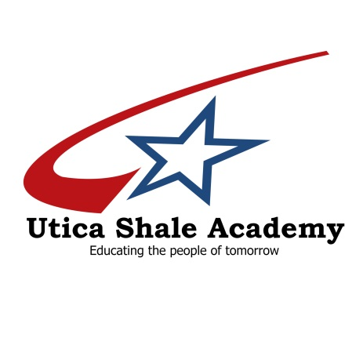

**Main Campus** Opened 2014-15 School Year

38095 State Route 39 Status: Open

Salineville Ohio 43945 IRN: 014830

Phone 1-330-679-8162 Director: Eric Sampson

Superintendent: Dr. Mark Furda Grades Served: 9-12

Website: [www.uticashaleschool.com](http://www.uticashaleschool.com) Enrollment: 71

Vision Statement

The Utica Shale Academy, through an innovative high school curriculum will serve as a leading educational institution for all students who seek to explore, develop, and enhance career opportunities as well as further advance their education.

Mission Statement

The Utica Shale Academy provides a unique and vigorous learning environment through a specialized academic program which responds to employers’ and industries' current and emerging and changing global workforce needs and expectations through business/school partnerships.  
  
Students will:

* Develop work habits that foster independence, self-awareness and commitment to personal growth.
* Achieve competency in industry and academic standards.

**2017-18 Compliance Assessment**

1 – Exceeded Compliance 2 – Met Compliance 3 – Did Not Meet Compliance

|  |  |  |  |  |
| --- | --- | --- | --- | --- |
| **School** | **Academic Performance** | **Fiscal**  **Performance** | **Organization & Operation** | **Legal**  **Compliance** |
| Utica Shale Academy | 3 | 2 | 2 | 2 |

**Academic Performance:** Does Not Meet Standards

USA changed report card designations for the 2017-2018 school year and operated as a Drop- Out recovery school. The model was necessary as the majority of students entering USA are credit deficient. Much determination is placed on credit recovery and making all efforts to remediate and graduate on time. For this reason, significant weight is placed on graduation rate as well as job ready certifications.

According to the 2017-2018 report card, USA does not meet standards in the overall school category. The four component grades are as follows:

* + 1. High School Test Passage Rate Does not meet standards (16.7%)
    2. Gap Closing Not Rated
    3. Progress Does not meet standard
    4. Graduation Rate Exceeds Standard (75 %)

For the 2017-18 school year, USA graduated 16 of 18 students

**Fiscal Performance:** Met

Utica Shale Academy utilized a properly licensed and bonded treasurer as the Fiscal Agent. Appropriate accounting procedures were followed in the Uniform Accounting System. Basic financial statements were filed timely with the state auditor, school board and sponsor. The five year forecast was submitted in accordance with ORC and Federal program money and IDEAB money used appropriately. JCESC worked with USA staff and Legal team to solidify their nonprofit status. A clean audit was issued by the Auditor of State and financials for the last two fiscal years are currently underway.

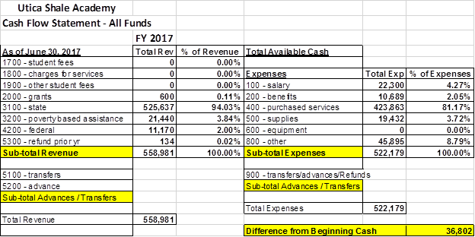

**Organization and Operation** Met

The Utica Shale Academy is currently operating in its fifth year. USA has been compliant in submitting required documentation. Additionally, JCESC spent significant time and resources assisting USA with attendance audits in light of new seat time verifications for blended and online schools. USA has performed well during site visits conducted by the JCESC and has been found compliant, thus far. USA has just completed their first year operating as a drop out recovery school. JCESC will review the school operations in a manner consistent with this model.

**Legal Compliance** Met

JCESC has conducted thorough reviews and site visits to the USA. This has helped to ensure full compliance with state and federal laws and with the terms of the sponsorship contract. USA will be entering the fifth year of a five year contract and discussion have begun to renew the contract centering on academic programs and school goals. The JCESC utilized a monitoring and review instrument that focused on the following:

|  |  |  |
| --- | --- | --- |
| *Area of Review* | *Areas of Compliance/Explanation* | *Verified* |
| Health and Safety | Certificate of Occupancy | Compliant |
| Health and Safety | BCI and FBI | Compliant |
| Health and Safety | Current Fire Inspection | Compliant |
| Health and Safety | School Safety Drills | Compliant |
| Health and Safety | School Health Inspection | Compliant |
| Health and Safety | School Safety Plan | Compliant |
| Health and Safety | Safety & Violence Training | Compliant |
| Health and Safety | Bloodborne Pathogens Training | Compliant |
| Health and Safety | Epinephrine Injectors Policy | Compliant |
| Health and Safety | Food Allergy Protection Policy | Compliant |
| Health and Safety | Immunization Records Policy | Compliant |
| Health and Safety | Missing Children Policy | Compliant |
| Health and Safety | Student Records Review | Compliant |
| Health and Safety | Wellness Policy | Compliant |
| Education Program | Special Education Plan | Compliant |
| Education Program | Child Find | Compliant |
| Education Program | College and Career Readiness & Financial Literacy | Compliant |
| Education Program | Dual Enrollment Policy for CC+ | Compliant |
| Education Program | HQT | Compliant |
| Education Program | LPDC | Compliant |
| Education Program | State Mandated Testing Plan & Schedule | Compliant |
| Governance | Board Mtg. Minutes | Compliant |
| Governance | Monthly Financial Review | Compliant |
| Governance | Fiscal Officer Qualifications | Compliant |
| Governance | Anti-Harassment & Bullying Policy | Compliant |
| Governance | Parental Involvement Policy | Compliant |
| Governance | Privacy Policy | Compliant |
| Governance | Suspension & Expulsion Policies | Compliant |
| Operations | Academic Calendar | Compliant |
| Operations | Liability Insurance | Compliant |
| Operations | RESA Program | Compliant |
| Operations | Review of Enrollment Records | Compliant |

Ohio Dept. of Ed. School Monitoring Summary: **Overall Compliant**



**Main Campus** Opened 2002

7401 Market Street Suite 519 Status: Open

Youngstown Ohio 44512 IRN: 148999

Phone 1-330-533-8755 Director: Brad Justice

Superintendent: Dr. Doug Hiscox Grades Served: 4-12

Website: www.mahoningunliminted.org Enrollment: 220

**Mission Statement**

The Mahoning Unlimited Classroom, an online public community school, strives to foster nurturing partnerships among parents, students and staff, collaborating to create an educational environment that prepares students for success in the 21st century.  
Students will:

***We Believe...***

* + All students can learn when given optimum learning experiences.
  + All students can reach higher levels of achievement.
  + Technology is a tool that enhances learning and affords students choices on how to approach their education.
  + The school's program should be challenging.  Students are expected to work online 27 hours per week to include online time, testing, and any lab time.

***Our Goals***

* + To provide a quality learning options to all students.
  + To create a learning environment that incorporates the best resources from a variety of media
  + To provide a learning system that creates partnerships between educators, parents, and caretakers.
  + To expose students to a variety of vocational opportunities that enhance their prospects for successful employment.
  + To provide an educational support system based on the Ohio state standards for "at-risk" students in a residential facility.

***Our Program***

* + Curriculum for grades 4-12 in all core subjects (Language Arts, Math, Social Studies, and Science) as well as a variety of HS electives.
  + Computer hardware including a content appropriate and filtered Internet connection.
  + Experienced and properly certified/licensed staff, including regular education instructors, special education instructors, school counselor and a school psychologist.  Behavior coaches and technical support personnel are also employed to the educational program.
  + A learning environment that incorporates the best resources from a variety of media, including online learning

**2017-18 Compliance Assessment**

1 – Exceeded Compliance 2 – Met Compliance 3 – Did Not Meet Compliance

|  |  |  |  |  |
| --- | --- | --- | --- | --- |
| **School** | **Academic Performance** | **Fiscal**  **Performance** | **Organization & Operation** | **Legal**  **Compliance** |
| Utica Shale Academy | 2 | 2 | 2 | 2 |

**Academic Performance:** Met

Mahoning Unlimited Classroom operates as a Dropout Recovery Program. Based on the 2017-18 report card, MUC has an overall school rating of Meets Standards. The four component grades are as follows:

* + 1. High School Test Passage Rate Does not meet standards (7.7%)
    2. Gap Closing Exceeds standards (61.7%)
    3. Progress Does not meet standards
    4. Graduation Rate Meets Standard (36.1%)

**Fiscal Performance:** Met

Mahoning Unlimited Classroom utilized a properly licensed and bonded treasurer as the Fiscal Agent. Appropriate accounting procedures were followed in the Uniform Accounting System. Basic financial statements were filed timely with the state auditor, school board and sponsor. The five year forecast was submitted in accordance with ORC and Federal program money and IDEAB money used appropriately. JCESC provided MUC with contact information for the possibility of reviewing and negotiating an alternative claw back payment plan which was granted by ODE.



**Organization and Operation** Met

The Mahoning Unlimited Classroom is currently operating in its Sixteenth year and first year of sponsorship with JCESC. MUC has been compliant in submitting required documentation. Additionally, JCESC has worked to develop processes and procedures for communication between the school and sponsor. This is in part to the new nature of the first year of sponsorship by JCESC as well as new sponsor reporting items. . MUC has performed well during site visits conducted by the JCESC and has been found compliant, thus far. MUC and JCESC revised the sponsor contract to add 4th grade to the current contract which now enables the school to serve students in grades 4-12. MUC is focused on capturing student seat time in an effort to increase the FTE of the student population.

**Legal Compliance** Met

JCESC has conducted thorough reviews and site visits to the MUC. This has helped to ensure full compliance with state and federal laws and with the terms of the sponsorship contract. MUC is completing the first year of the agreement with JCESC as sponsor. The JCESC utilized a monitoring and review instrument that focused on the following:

|  |  |  |
| --- | --- | --- |
| *Area of Review* | *Areas of Compliance/Explanation* | *Verified* |
| Health and Safety | Certificate of Occupancy | Compliant |
| Health and Safety | BCI and FBI | Compliant |
| Health and Safety | Current Fire Inspection | Compliant |
| Health and Safety | School Safety Drills | Compliant |
| Health and Safety | School Health Inspection | Compliant |
| Health and Safety | School Safety Plan | Compliant |
| Health and Safety | Safety & Violence Training | Compliant |
| Health and Safety | Bloodborne Pathogens Training | Compliant |
| Health and Safety | Epinephrine Injectors Policy | Compliant |
| Health and Safety | Food Allergy Protection Policy | Compliant |
| Health and Safety | Immunization Records Policy | Compliant |
| Health and Safety | Missing Children Policy | Compliant |
| Health and Safety | Student Records Review | Compliant |
| Health and Safety | Wellness Policy | Compliant |
| Education Program | Special Education Plan | Compliant |
| Education Program | Child Find | Compliant |
| Education Program | College and Career Readiness & Financial Literacy | Compliant |
| Education Program | Dual Enrollment Policy for CC+ | Compliant |
| Education Program | HQT | Compliant |
| Education Program | LPDC | Compliant |
| Education Program | State Mandated Testing Plan & Schedule | Compliant |
| Governance | Board Mtg. Minutes | Compliant |
| Governance | Monthly Financial Review | Compliant |
| Governance | Fiscal Officer Qualifications | Compliant |
| Governance | Anti-Harassment & Bullying Policy | Compliant |
| Governance | Parental Involvement Policy | Compliant |
| Governance | Privacy Policy | Compliant |
| Governance | Suspension & Expulsion Policies | Compliant |
| Operations | Academic Calendar | Compliant |
| Operations | Liability Insurance | Compliant |
| Operations | RESA Program | Compliant |
| Operations | Review of Enrollment Records | Compliant |

Ohio Dept. of Ed. School Monitoring Summary: **Overall Compliant**